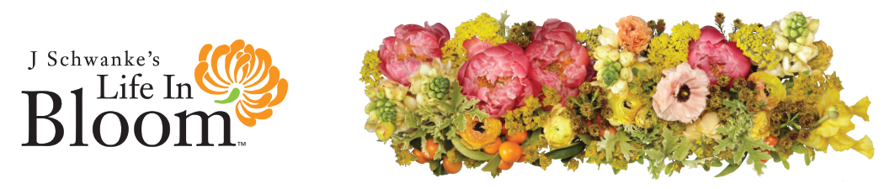
For Immediate Release Contact: J Schwanke
Phone: 616-446-6086
Email: j@uBloom.com

“Dedicated underwriters share the power of flowers in ‘Life In Bloom,’ season three.”

Grand Rapids, MI, April 5, 2021 – J Schwanke’s Life in Bloom, a half-hour lifestyle show focused on flowers, returns for its third season, beginning in April of 2021. Each episode informs viewers of the positive impact flowers can have on health and well-being, every day. Creator and host J Schwanke, a fourth-generation florist whose passion for flowers is infectious, reminds viewers that the show is not possible without underwriters.

“I’m ever grateful to our underwriters of the show – past, present, and future – because it’s their commitment to the power of flowers that allows us to produce the show and keeps it on the air. In fact, through the first two seasons, the show has aired continuously in 85-93% of the U.S. - around 90 million households per week!”

“I’m thrilled that previous underwriters Albertsons Companies, CalFlowers, and Sunshine Bouquet have returned for season three,” explained Schwanke. “And I am overjoyed to welcome two new underwriters for season three – Dollar Tree, and closed caption underwriter Holland America Flowers.”

“Inspiring creativity is at the core of Dollar Tree and we are proud to partner as an underwriter of J Schwanke’s Life In Bloom, which reaches millions of DIY enthusiasts every week,” said Bobby Patrick, Dollar Tree’s Senior Vice President of Merchandising, Variety. “At the $1 price point, Dollar Tree stores provide a variety of affordable crafting, floral, gardening and holiday products to help customers celebrate seasons and events.”

“I am quite proud to be part of Life in Bloom,” said Benno Dobbe, Owner of Holland America, “My family and I were already fans of the show, so we asked how we could support it. I especially enjoy J’s genuine interaction with his guests – it’s very natural. Of course, the flower arrangements look beautiful, as well! The Dobbe families and our entire Holland America Flowers team are very much looking forward to the new season,” Dobbe concluded.

“Part of the enjoyment of cut flowers comes from learning a variety of ways to utilize flowers in our daily lives, and understanding important aspects, such as how flowers enhance our sense of well-being and affect our mood,” noted Steve Dionne, Executive Director for original underwriter, CalFlowers. “We are proud to support the ongoing success of Life in Bloom.”

“What I love about J and the show is his ability to showcase the benefits that fresh flowers offer, and that arranging and enjoying flowers at home is easy,” echoed Debora Steier, of Albertsons Companies, an underwriter from the show’s beginning. “He shows viewers every day how relaxing and rewarding it is to include flowers in your life, and we couldn’t agree more.”

Sunshine Bouquet Company – likewise, with the show since it’s inception – also returns as an underwriter of season three’s thirteen new episodes.

“I’m very happy to be able to deliver a full season of thirteen new episodes for public television,” says Schwanke, “which is always a challenge, but doing so as we all navigated the pandemic, was an exceptional situation.”

“We followed safety guidelines as determined by the motion picture and television industries, and I am so thankful for the show’s committed crew and our guests – along with the underwriters who provide the resources to make it all possible – even during a pandemic,” concluded Schwanke. “Everyone’s dedication really speaks to the power of flowers and the message of how the presence of flowers improves our lives.”

Season three of J Schwanke’s Life in Bloom is broadcast on public television stations across the U.S., including Create TV stations. The series is presented and distributed by American Public Television. Check local public television listings or visit uBloom.com/find to find out when J Schwanke’s Life in Bloom airs in your area.

# # #

About J Schwanke
Fourth-generation florist J Schwanke is a flower expert, flower content producer and professional speaker, regarded as the most trusted voice in the flower industry. He was actually born at a flower convention and grew up in his family’s greenhouses. His website, uBloom.com, offers flower fans everywhere the opportunity to learn and experience the fun of flowers and flower arranging, 24/7! J is the host and creator of the TV show J Schwanke’s Life In Bloom, beginning its third season on public television. J has given flower demonstrations in all 50 states, Canada and England. Highlights include the Epcot International Flower and Garden Festival, Art in Bloom, Bouquets to Art, San Francisco Flower & Garden Show, and Flowers at Kensington. The J Schwanke YouTube Channel has over 80,000 subscribers and more than 10 million views. J is the author of Fun with Flowers, which received a Silver Living Now Book Award. His most recent book, Bloom 365 – The Essential Guide to Arranging Flowers Every Day, was awarded the Gold IPPY (Home and Garden category) by the Independent Publisher Book Awards. Bloom 365 features 365 tips, tricks, and techniques to make flower arranging easier.

American Public Television
American Public Television (APT) is the leading syndicator of high-quality, top-rated programming to the nation’s public television stations. APT distributes one-fourth of the top 100 highest-rated public television titles in the U.S. Founded in 1961, among its 250 new program titles per year, APT programs include prominent documentaries, performance, news and current affairs programs, dramas, how-to programs, children’s series and classic movies. America’s Test Kitchen From Cook’s Illustrated, Cook’s Country, AfroPoP, Rick Steves’ Europe, Chris Kimball’s Milk Street Television, Front and Center, Doc Martin, Nightly Business Report, Midsomer Murders, A Place to Call Home, Lidia’s Kitchen, Globe Trekker, New Orleans Cooking with Kevin Belton, Simply Ming, and P. Allen Smith’s Garden Home are a sampling of APT’s programs, considered some of the most popular on public television. APT licenses programs internationally through its APT Worldwide service. Now in its 13th year, Create®TV — featuring the best of public television's lifestyle programming — is distributed by American Public Television. APT also distributes WORLD™, public television’s premier news, science and documentary channel. To find out more about APT’s programs and services, visit APTonline.org.

